PART 1

Learning rate=0.005

|  |  |  |  |
| --- | --- | --- | --- |
| epoch | Ɵ0 | Ɵ1 | cost |
| 100 | 12.23 | 15.32 | 560.49 |
| 500 | 35.14 | 8.81 | 273.51 |
| 1000 | 54.00 | 3.39 | 116.81 |

Learning rate=0.0005

|  |  |  |  |
| --- | --- | --- | --- |
| epoch | Ɵ0 | Ɵ1 | cost |
| 100 | 2.85 | 7.084 | 1275.38 |
| 500 | 8.40 | 15.31 | 622.44 |
| 1000 | 12.24 | 15.41 | 560.63 |

Learning rate=0.05

|  |  |  |  |
| --- | --- | --- | --- |
| epoch | Ɵ0 | Ɵ1 | cost |
| 1000 | 85.72 | -5.86 | 15.15 |
| 1500 | 85.73 | -5.80 | 15.15 |

Learning rate=0.5

|  |  |  |  |
| --- | --- | --- | --- |
| epoch | Ɵ0 | Ɵ1 | cost |
| 1000 | 84.67 | -6.11 | 17.56 |

Learning rate=0.1

|  |  |  |  |
| --- | --- | --- | --- |
| epoch | Ɵ0 | Ɵ1 | cost |
| 1000 | 85.71 | -5.88 | 15.26 |

Minimum error/ Cost=15.15 for Ɵ0=85.72 and Ɵ1=-5.86.

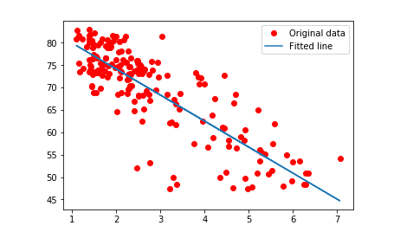

PART 2

a.

From the above collected data

learning rate v/s cost

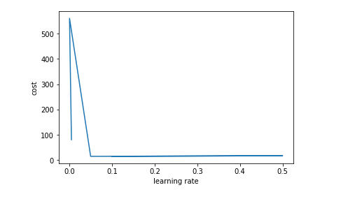

Epoch v/s cost

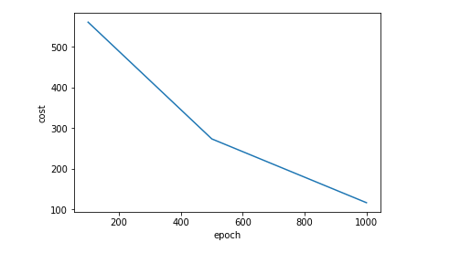

b, c:

learning_rate=0.04

epoch=1000

|  |  |  |  |
| --- | --- | --- | --- |
|  | Batch | Stochastic | Gradient |
| θ0 | 89.20802811 | 78.53744148623737 | 85.71903 |
| θ1 | -6.72152272 | -5.324618414138 | -5.8876305 |
| cost | - | - | 15.26245 |
| Time taken | 0.33463634500003536 | 0.8141794109997136 | 79.91002489599987 |

We observe that the time complexity increases in the order of Batch < Stochastic <Gradient

We also observe that best approach to initialize Ɵ0 and Ɵ1 is Batch as it takes less time.

PART 3

a.

We observe form PART1 cost minimizes as the learning rate and epoch increases. But increasing learning rate beyond a threshold will again lead to increase of error.

From PART 2 we see that optimization also depends on the approach chosen, as gradient descent takes more time and batch approach takes less time.

b.

Another cost function that can be implemented is

CNC= Ʃ(XY)

(ƩX2)1/2 (ƩY2)1/2